* check whether the i915 driver is properly installed and loaded
* Kmd :sudo modprobe i915
* navigate to folder gfxsv@gfxsv123404201:~$ cd binocle-3.3/

+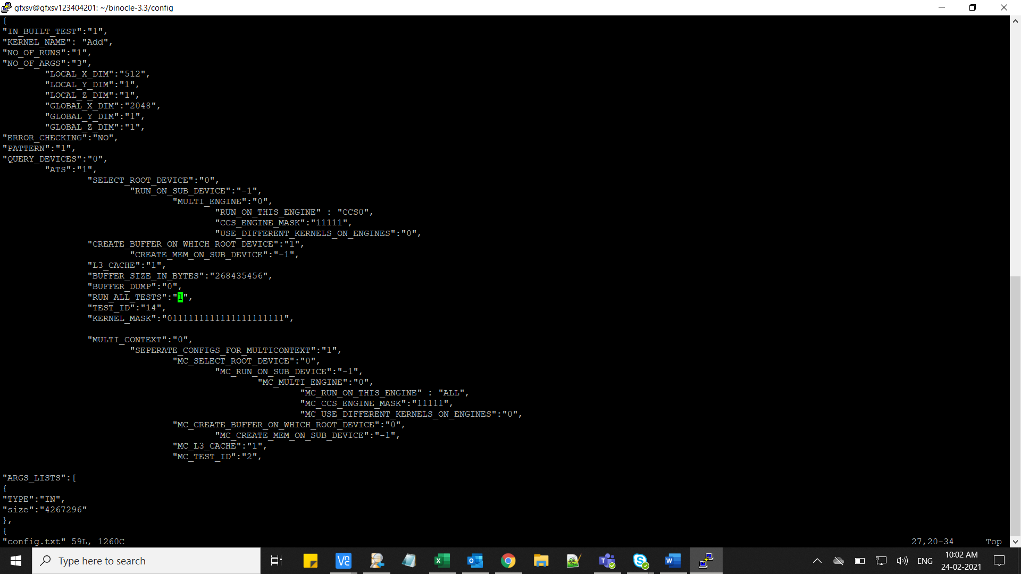

* now navigate to config folder where you find the configuration file i.e, config.txt
* To run all the tests at one run use
* Make changes : "RUN_ALL_TESTS":"1",
* If only particular test to be run make "RUN_ALL_TESTS":"0",
* And mention"TEST_ID":"14", the test i.d which needs to be run .
* Below attached the test names with their i.d ‘s .

* After making changes to the configuration files ,
* Use cd .. and move to binocle_3.3/bin folder
* And run the ./BinOCLe to run the test , which is set in the config file.

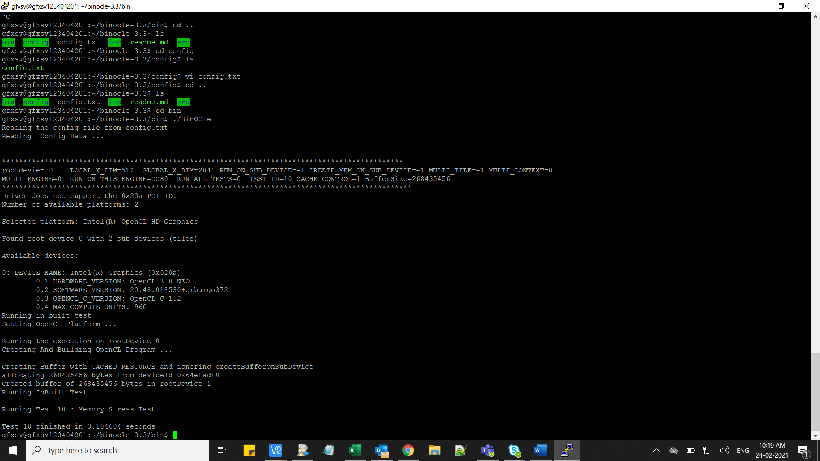

* Test will run as mentioned in the above picture,
* If we want to run the same test in different configurations, configuration file need to be changed in the target.

|  |  |
| --- | --- |
| config_0.txt | multiTile, |
| config_6.txt | multiEngine, MultiTile |
| config_9.txt | MultiContext |

|  |  |
| --- | --- |
| config_14.txt | multiContext, Sametile |

|  |  |
| --- | --- |
| config_10.txt | multicontext, crosstile |

* Above are the different configurations